**VISVESVARAYA TECHNOLOGICAL UNIVERSITY**

“Jnana Sangama”, Belagavi-590018.

##### A Project Report on

**“Real-Time Drowsiness Detection Using Machine Learning For Enhanced Road Safety**”

###### *Submitted in the partial fulfillment of the requirements for the award of the degree of*

***Bachelor of Engineering in Computer Science and Engineering***

Submitted by

***Aymaan Khan(1RF21CS020)***

***Ayush Prajapati (1RF21CS022)***

***Bhoopalam AVS(1RF21CS023)***

***Tushar Arora(1RF21CS116)***

**Under the Guidance of**

**Dr. Roopashree Shailendra,**

**Assistant Professor,**



Department of Computer Science and Engineering

RV INSTITUTE OF TECHNOLOGY AND MANAGEMENT (Affiliated to Visvesvaraya Technological University, Belagavi & Approved by AICTE, New Delhi) JP Nagar 8th Phase , Kothanur,Bengaluru-560076

2023-2024

**RV INSTITUTE OF TECHNOLOGY AND MANAGEMENT**

(Affiliated to Visvesvaraya Technological University, Belagavi & Approved by AICTE, New Delhi)

**DEPARTMENT OF COMPUTER SCIENCE AND ENGINEERING**



**CERTIFICATE**

Certified that the project work titled **‘Real-Time Drowsiness Detection Using Machine Learning For Enhanced Road Safety’** is carried out by **Aymaan Khan (1RF21CS020), Ayush Prajapati (1RF21CS022), Bhoopalam AVS (1RF21CS023), Tushar Arora (1RF21CS116),** who are bonafide students of RV Institute of Technology and Management, Bangalore, in partial fulfillment for the award of degree of **Bachelor of Engineering** in **Computer Science and Engineering** of the Visvesvaraya Technological University, Belgaum during the year **------**. It is certified that all corrections/suggestions indicated for the internal Assessment have been incorporated in the report deposited in the departmental library. The project report has been approved as it satisfies the academic requirements in respect of project work prescribed by the institution for the said degree.

| Dr. Roopashree S, | **Dr. Malini M Patil** | **Dr. Jayapal R** |
| --- | --- | --- |
| Assistant Professor, | Professor & Head, | Principal, |
| Department of CSE, | Department of CSE, | RVITM, Bengaluru-76 |
| RVITM, Bengaluru-76 | RVITM, Bengaluru-76 |  |

**Signature of Guide Signature of Head of the Department Signature of Principal**

**RV INSTITUTE OF TECHNOLOGY AND MANAGEMENT**

(Affiliated to Visvesvaraya Technological University, Belagavi & Approved by AICTE, New Delhi)

**DEPARTMENT OF COMPUTER SCIENCE AND ENGINEERING**



**DECLARATION**

We, **Aymaan Khan (1RF21CS020), Ayush Prajapati (1RF21CS022), Bhoopalam AVS (1RF21CS023), Tushar Arora (1RF21CS116)**, the students of seventh semester B.E, hereby declare that the project titled **“**REAL-TIME DROWSINESS DETECTION USING MACHINE LEARNING FOR ENHANCED ROAD SAFETY**”** has been carried out by us and submitted in partial fulfillment for the award of degree of Bachelor of Engineering in **Computer Science and Engineering.** We do declare thatthis work is not carried out by any other students for the award of degree in any other branch.

**Place: Bangalore Signature**

**Date: 1. Aymaan Khan (1RF21CS020)**

**2.** **Ayush Prajapati (1RF21CS022)**

**3. Bhoopalam AVS (1RF21CS023)**

**4. Tushar Arora (1RF21CS116)**

**ACKNOWLEDGEMENT**

The successful presentation of the **REAL-TIME DROWSINESS DETECTION USING MACHINE LEARNING FOR ENHANCED ROAD SAFETY** would be incomplete without the mention of the people who made it possible and whose constant guidance crowned my effort with success.

We would like to extend my gratitude to the **RV Institute of Technology and Management**, Bengaluru, and **Dr. Jayapal R,** Principal, RV Institute of Technology and Management, Bengaluru for providing all the facilities to carry out the Internship.

We thank **Dr. Malini M Patil**, Professor and Head, Department of Computer Science and Engineering, RV Institute of Technology and Management, Bengaluru, for her initiative and encouragement.

We would like to thank our Project Guide, **Dr. ROOPASHREE SHAILENDRA,** Assi stant Professor, Department of Computer Science and Engineering, RV Institute of Technology and Management, Bengaluru, for her constant guidance and inputs.

We would like to thank all the **Teaching** Staff and **Non-Teaching** Staff of the college for their co- operation.

Finally, we extend my heart-felt gratitude to my **family** for their encouragement and support without which we would not have come so far. Moreover, we thank all my **friends** for their invaluable support and cooperation.

**1. AYMAAN KHAN (1RF21CS020)**

**2. AYUSH PRAJAPATI (1RF21CS022)**

**3. BHOOPALAM AVS (1RF21CS023)**

**4. TUSHAR ARORA (1RF21CS116)**

**ABSTRACT**

Driver drowsiness significantly contributes to road accidents globally, posing a severe threat to public safety. Traditional countermeasures like roadside tests and in-vehicle monitoring systems often fail to provide real-time detection and timely responses, thus inadequately preventing accidents. This report explores the development of a real-time driver drowsiness detection system leveraging advanced image processing and machine learning techniques. By analyzing visual cues such as facial features, eye states, and head movements, the proposed system aims to accurately identify signs of drowsiness and provide immediate alerts.

Key methodologies include face detection using HOG+SVM, eye detection, blink detection, forehead dot tracking, and an audio-based alert system. These techniques ensure high accuracy in detection while maintaining a non-intrusive and user-friendly experience for the driver. The system is designed to function effectively under various lighting conditions and environmental factors, ensuring consistent performance.

The primary objective is to enhance road safety by reducing drowsiness-related accidents through continuous monitoring and immediate feedback. This involves developing a scalable and robust solution that leverages the strengths of image processing and machine learning to monitor facial features and eye movements accurately. By addressing the limitations of current methods, this solution aims to offer a reliable and efficient approach to real-time drowsiness detection.

The implementation of this system is crucial for improving road safety, reducing accident rates, and ultimately saving lives. The proposed solution not only aims to bridge the gap between current limitations and the need for real-time, accurate drowsiness detection but also contributes to safer driving environments. This report details the development process, challenges encountered, and the potential impact of this innovative approach on enhancing public safety on the roads.

|  |  |  |
| --- | --- | --- |
|  |  |  |
|  |  |  |
|  |  |  |

**CHAPTER-1**

**INTRODUCTION**

* 1. **Introduction**

Driver drowsiness is a critical issue contributing significantly to road accidents worldwide, posing a severe threat to public safety. Traditional methods to counteract this issue, such as roadside tests and in-vehicle monitoring systems, often fall short in providing real-time detection and immediate response capabilities, thus failing to prevent accidents effectively. Studies indicate that drowsy driving impairs reaction times, attention, and decision-making abilities, making it as dangerous as driving under the influence of alcohol [17]. Despite various measures to raise awareness and implement preventive strategies, drowsiness-related accidents continue to be a significant public health concern, leading to numerous fatalities and injuries each year [23]. The advent of advanced technologies, particularly in the fields of image processing and machine learning, offers new avenues to address this problem more efficiently and accurately, providing a promising solution to enhance road safety [21].

The integration of image processing and machine learning techniques can revolutionize the detection of driver drowsiness. By analyzing visual cues such as facial features, eye state, and head movements, these technologies can accurately identify signs of drowsiness and trigger appropriate alerts, thus preventing accidents [18]. This approach not only improves the accuracy of detection but also ensures that the system is non-intrusive and user-friendly, making it a crucial tool for enhancing road safety [19]. The need for such a system is evident, as it can continuously monitor the driver's state and provide instant alerts, thereby preventing potential accidents and saving lives [25]. With the ability to operate under various lighting conditions and environmental factors, these systems promise consistent performance, offering a reliable solution to a pervasive problem [22].

The primary objective of this project is to develop a robust real-time drowsiness detection system using advanced image processing and machine learning methodologies. This involves implementing techniques such as face detection using HOG+SVM, eye detection, blink detection, forehead dot tracking, and an audio-based alert system [16][11][14]. The goal is to create a system that can monitor the driver continuously and provide immediate alerts upon detecting signs of drowsiness. By addressing the limitations of current methods, this project aims to bridge the gap between existing technologies and the need for real-time, accurate drowsiness detection [15]. Ultimately, the project aims to enhance road safety by preventing drowsiness-related accidents, thereby contributing to safer driving environments and saving lives [20].

**1.2 Problem Statement**

Falling asleep while driving is one of the significant causes of road accidents that have caused numerous deaths and the destruction of property. The main problem is that the existing methods cannot provide continuous real-time monitoring and alerts in time to prevent accidents induced by drowsiness. Traditional in-vehicle monitoring systems are not, for the most part, real-time and lack precision in detecting early signs of drowsiness. It is thus critical to develop a reliable and efficient system for detecting real-time driver drowsiness and offering timely feedback. The system should work without fail in different lighting conditions and environmental factors, performing uniformly. So, the statement of the problem lies in developing a scalable, robust solution with the use of approaches in image processing and machine learning for proper monitoring of facial features along with eye movement. This would improve road safety, reduce accident rates, and ultimately save lives. In this respect, the current drawbacks, as well as the necessity of real-time, accurate drowsiness detection in the current scenario, will be addressed through the proposed solution, which is likely to ensure a safer driving environment.

**CHAPTER- 2**

**OBJECTIVES OF THE PROJECT**

The project aims to create a real-time driver drowsiness detection system to enhance road safety by alerting drivers before they fall asleep:

1. **Face and Eye Detection with Forehead Dot Tracking:** The system employs a combination of Histogram of Oriented Gradients (HOG) and Support Vector Machine (SVM) algorithms to accurately detect the driver’s face in real-time. Upon successful face detection, the system further identifies the driver's eyes, monitoring their state to determine if they are open or closed. Additionally, the system tracks the distance between the driver's forehead and the steering wheel. This multifaceted approach ensures that any deviations in facial features or head position, which are indicative of drowsiness, are promptly detected, allowing for early intervention.

2. **Prolonged Blink Detection with Audio Alert:** The system leverages the Eye Aspect Ratio (EAR) to measure and analyze the duration of eye closure. Prolonged eye closure is a significant indicator of drowsiness. When the EAR algorithm detects that the driver's eyes remain closed for an extended period, the system triggers an audio alert. This alarm is designed to wake the driver immediately, providing a crucial warning that helps prevent accidents caused by falling asleep at the wheel. By combining visual and auditory cues, the system offers a robust solution for enhancing driver safety on the road.

**CHAPTER- 3**

**LITERATURE SURVEY**

In recent years, significant advancements have been made in the field of drowsiness detection and alarm systems, leveraging technologies such as deep learning, computer vision, and IoT. A comprehensive literature survey was conducted to explore various methodologies and datasets used in these systems, highlighting their effectiveness in enhancing driver safety and public health protocols.

Militante SV and Dionisio NV described a real-time facemask recognition system using deep learning, designed to trigger an alarm when a facemask is not detected. The system employed a convolutional neural network (CNN) for image classification, using a dataset of 20,000 images to recognize mask-wearing and measure physical distancing[1].Siddiqui et al. presented a method for detecting driver drowsiness using Ultra-Wide Band (UWB) radar combined with convolutional spatial feature engineering and AI. Their system captures respiration data to differentiate between drowsy and non-drowsy states, using a dataset of ultra-wideband radar data segmented into one-minute chunks and transformed into grayscale images for analysis[25].

Moujahid A et al. introduced an efficient and compact face descriptor for detecting driver drowsiness, utilizing advanced image processing techniques. Their experiments were conducted on the NTH Drowsy Driver Detection (NTHUDDD) dataset[2]. Naderpour et al. developed a novel approach to enhancing alarm systems through graph modeling, utilizing advanced graph-based algorithms. The dataset used was the Tennessee Eastman Process Simulink model[3]. Pellegrini et al. optimized algorithms for rockfall alarm systems using fiber polarization sensing, aiming to enhance detection accuracy. No specific dataset was mentioned as prediction was based on fiber output[4].

Sonia Diaz-Santos et al. developed a client-server architecture for real-time drowsiness detection in vehicles using 5G networks. Their system combines facial recognition for driver authentication and continuous eye monitoring, leveraging edge computing for real-time processing. The dataset used, sourced from DataFlair, includes approximately 7,000 images of human eyes captured in diverse environmental settings, classified into "open" or "closed" categories[21]. Wang M.H et al. provided an overview of advanced methods and current trends in diagnosing and treating eye diseases, particularly focusing on dry eye disease (DED) and the use of AI in ophthalmology. Their comprehensive review categorizes DED diagnostic methods into AI-related groups and proposes future research directions. An aggregation of DED digital datasets was used for this study[22].

Beles H et al. developed a system that detects driver drowsiness using a combination of electrooculography (EOG) signals and eye state images, integrating with advanced driver assistance systems (ADAS) to monitor and analyze driver alertness. They utilized a fuzzy decision algorithm for driver drowsiness monitoring, although no specific dataset was mentioned[23]. Das et al. discussed a system for detecting driver drowsiness using IoT and deep learning, employing a CNN-LSTM model for sleepiness detection. Various algorithms such as EM-CNN, VGG-16, GoogLeNet, AlexNet, and ResNet50 were used to analyze video clips of driver motion sequences. The dataset comprised video clips analyzed by these deep learning models[24].

Das C et al. reviewed various methodologies and technologies used in smart alarm systems for drowsiness detection, highlighting their effectiveness and limitations. This review paper did not mention specific datasets as it summarized existing research[5]. In the area of face detection, Waseem S et al. provided a comprehensive overview of deepfake technologies, focusing on face and expression swapping techniques. Publicly available deepfake datasets were used for benchmarking detection systems[6]. Li N et al. created a Chinese face dataset tailored for face recognition in uncontrolled classroom environments, aiming to improve system robustness. The UCEC-Face dataset includes 7,395 images of 130 subjects[7].

Qi et al. proposed a real-time face detection method utilizing blink detection, enhancing accuracy and efficiency. Datasets used included NUAA, CASIA-SURF, and CASIA-FASD[8]. Dash et al. explored advancements and challenges in face recognition and detection technologies in a comprehensive review, providing insights into their applications and limitations[9]. Militante SV and Dionisio NV presented a deep learning-based system for detecting face masks and enforcing physical distancing, showcased at the 2020 ICVEE conference. Their dataset comprised 20,000 images uniformly cropped to 224x224 pixels[10].

In blink detection, De la Cruz et al. introduced Eye-LRCN, a long-term recurrent convolutional network for accurately detecting eye blink completeness. No specific dataset was used as the method combines CNNs and RNNs[11]. Cai et al. detailed a method for detecting face fatigue features in complex scenes, enhancing accuracy under varied environmental conditions. No specific dataset was mentioned[12]. Madni et al. utilized a novel transfer learning approach for driver drowsiness detection based on eye movement behavior, using an eye movement behavior imagery dataset[13].

Hong S et al. employed a Blink Estimation with Domain Adversarial Training (BEAT) Network for blink detection under varying lighting conditions. No specific datasets were mentioned[14]. Shahbakhti et al. proposed a fusion method combining EEG and eye blink analysis for detecting driver fatigue, using two datasets for parameter tuning and testing[15]. Salman et al. employed ensemble convolutional neural networks for driver drowsiness detection using the YawDD dataset, enhancing accuracy in recognizing drowsiness based on yawning behavior[16].

Safarov et al. proposed a real-time drowsiness detection system integrating computer vision and eye-blink analysis, using custom data for model training[17]. Albadawi Y, AlRedhaei A, and Takruri M introduced a real-time machine learning-based system for driver drowsiness detection using visual features, employing the National Tsing Hua University driver drowsiness detection dataset[18]. Deng W and Wu R presented a real-time driver drowsiness detection system utilizing facial features, using datasets like CelebA and YawDD along with video data from volunteers simulating drowsy driving states[19].

Hasan, Watling, and Larue validated a multimodal drowsiness detection system using explainable machine learning methods, integrating physiological signals recorded during a simulated driving scenario. The dataset included EEG, EOG, and ECG signals[20].

This literature survey highlights the diverse methodologies and datasets employed in recent research to enhance driver safety and public health protocols, showcasing significant advancements in AI, deep learning, and computer vision technologies.

**CHAPTER- 4**

**METHODOLOGY**

The methodology employed in the development of the proposed Drowsiness Detection and Yawning Detection (DDD) system is comprehensively detailed in this section. The methodology encompasses several key components:

1. **System Design**: An overview of the system architecture and design principles.
2. **Dataset Description**: Detailed information about the dataset used, including its source, composition, and characteristics.
3. **Implementation Process**: An in-depth discussion of the four main steps involved in the implementation:
   * **Preprocessing**: Initial steps to prepare the data for analysis.
   * **Feature Extraction**: Techniques used to identify and extract relevant features from the data.
   * **Classification**: Algorithms and approaches used to classify the data and make predictions.

**4.1 System Design**

The flowchart in Figure 1 illustrates the design flow of the proposed drowsiness and yawning detection system. The design comprises five main steps:

1. **Video Capture and Frame Extraction**: The system initiates by capturing a live video feed from a webcam to monitor the driver's head. Frames are continuously extracted from this video stream for subsequent analysis.
2. **Preprocessing**:
   * Initially, each frame is resized to a consistent width to ensure uniformity and reduce computational load.
   * The resized frames are then converted to grayscale to simplify processing and focus on essential structural features.
   * For detecting the eyes and mouth regions, the Dlib Histogram of Oriented Gradients (HOG) face detector is employed. This is followed by the Dlib facial landmarks detector, which identifies and extracts the eyes, mouth and nose bridge regions within each frame.
3. **Feature Extraction**:
   * The system calculates several key features from each frame, including the Eye Aspect Ratio (EAR) and Mouth Aspect Ratio (MAR). These ratios are derived from specific distances between facial landmarks around the eyes and mouth.
   * Additionally, a point above the nose bridge and between the eyes is identified to monitor head position. This point serves as a reference to detect head nodding, which is another indicator of drowsiness.
4. **Alert Mechanism and Decision Making**:
   * The system continuously monitors the EAR to detect prolonged eye closures, which might indicate drowsiness. If the EAR falls below a predefined threshold for a certain number of consecutive frames, an alert is triggered.
   * Similarly, the MAR is monitored to detect yawning. If the MAR exceeds a predefined threshold for several consecutive frames, a yawning alert is activated.
   * To enhance safety, the system also tracks the position of a point above the nose bridge. If this point drops below a predefined line (calculated to be 1 cm below the forehead point) for a sustained duration (e.g., 20 frames), an additional alert is triggered.
5. **Real-time Processing and Moving Window Concept**:
   * The system performs real-time analysis by continuously updating with the latest feature vectors from consecutive frames.
   * Alerts for drowsiness and yawning are based on monitoring conditions being met for a specified number of consecutive frames, rather than using a fixed-size window.
   * When a new frame is recorded, its feature vector is analyzed immediately, and decisions are updated almost instantly to ensure rapid response to changes in the driver's state.

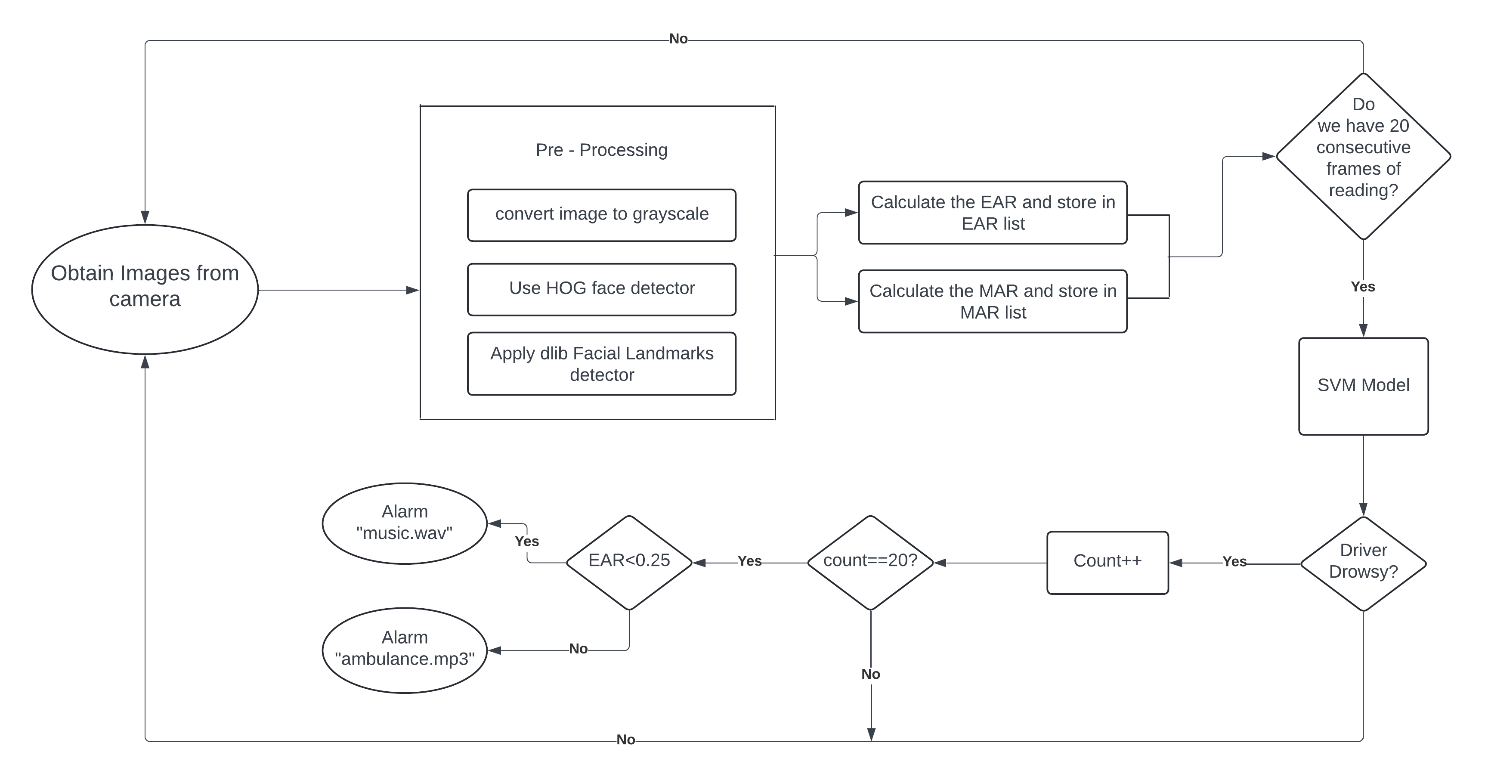

**Fig 4.1: Process Flowchart**

By following this structured approach, the proposed system is capable of detecting drowsiness and yawning in real-time, providing timely alerts to enhance driver safety and prevent accidents. The system's rapid response ensures that any signs of drowsiness or yawning are quickly identified, allowing for prompt intervention.

**4.2 Dataset:**

In this work, we have made our own custom dataset where we have used a total of 14 images inspired from the NTHUDDD dataset. All these images were of jpg format and of the dimension **640 x 480** pixels. We had two sub folders, one for storing images that showed drowsiness and one for storing images that did not depict drowsiness. A total of 7 different subjects were used who belong to different nationalities. These images are real-time images of truck drivers while driving on the road and is the accurate representation for our dataset.

| **Driver’s Behaviours** | **Description** |
| --- | --- |
| Looking aside | When the head turns left or right |
| Talking and laughing | When talking or laughing |
| Sleepy-eyes | When eyes slowly close due to drowsiness |
| Yawning | When mouth open wide due to drowsiness |
| Nodding | When head falls forward when drowsy |
| Drowsy | When the driver visually looks sleepy, showing signs such as slowly blinking, yawning, and nodding |
| Stillness | When normally driving |

**Fig 4.2: Terminologies used**

**4.3 Implementation**

### **Preprocessing**

In the preprocessing stage, the colored frames captured from the video are first converted to grayscale to simplify further processing. To detect the facial features such as eyes, mouth, and nose bridge, the system utilizes Dlib's Histogram of Oriented Gradients (HOG) face detector. This detector identifies the face region in the frame, providing the necessary coordinates to isolate the face.

Following face detection, the Dlib facial landmarks detector is employed. This detector estimates the location of 68 points on the face, creating a detailed map of the facial structures. Specifically, it extracts the regions for the eyes, mouth, and nose bridge, which are crucial for drowsiness detection. The eye landmarks are used to compute the Eye Aspect Ratio (EAR), while the mouth landmarks help calculate the Mouth Aspect Ratio (MAR).

In addition to detecting eyes and mouth, the system identifies a specific point on the nose bridge, which is critical for head pose estimation. This point, located between the eyes and above the nose, serves as a reference for determining the head's position and movement.

**Feature Extraction**

Features such as EAR, MAR, and the nose bridge position are computed for each frame and stored in a feature vector. These vectors provide the necessary data to assess the driver's state continuously, enabling the system to detect drowsiness reliably. By combining these metrics, the system can effectively identify signs of drowsiness, such as prolonged eye closure, yawning, and head nodding, ensuring accurate and timely alerts.

**Eye Aspect Ratio (EAR)**:

The EAR is a widely used metric for detecting eye closure. It is calculated using the distances between specific facial landmarks around the eyes. For each eye, the distances between the vertical eye landmarks are averaged and then divided by the distance between the horizontal eye landmarks. This ratio helps in determining whether the eyes are closed or open.

It is computed using the distances between specific points around the eyes.

**Facial Landmarks Used**: For each eye, 6 points are used:

* Left Eye: Points 37, 38, 39, 40, 41, and 42
* Right Eye: Points 43, 44, 45, 46, 47, and 48

**Calculation**: The EAR is calculated as follows:



For the left eye:

* P1: 37 P2: 38
* P3: 39 P4: 40
* P5: 41 P6: 42

For the right eye:

* P1: 43 P2: 44
* P3: 45 P4: 46
* P5: 47 P6: 48

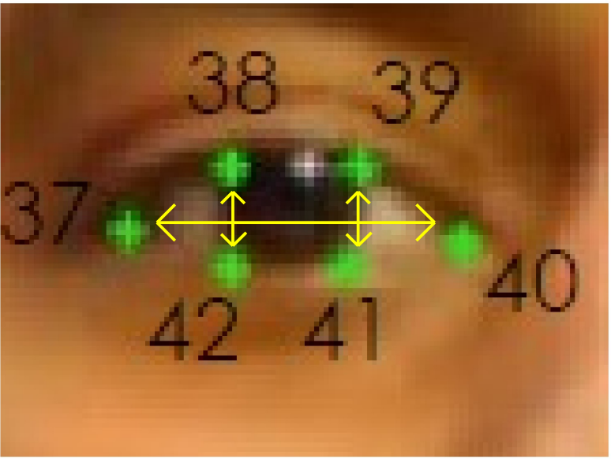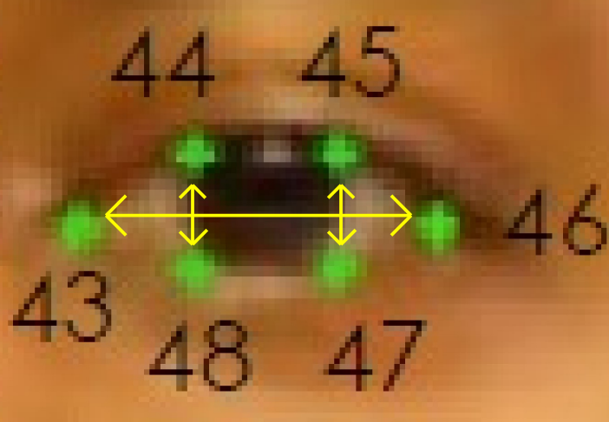

**Fig.4.3: Points on Left Eye, Right Eye**

**Threshold Value**: The typical threshold value for detecting drowsiness or eye closure is around 0.25. If the EAR drops below this threshold for a certain number of frames (e.g., 20 frames), it indicates that the eyes are closed.

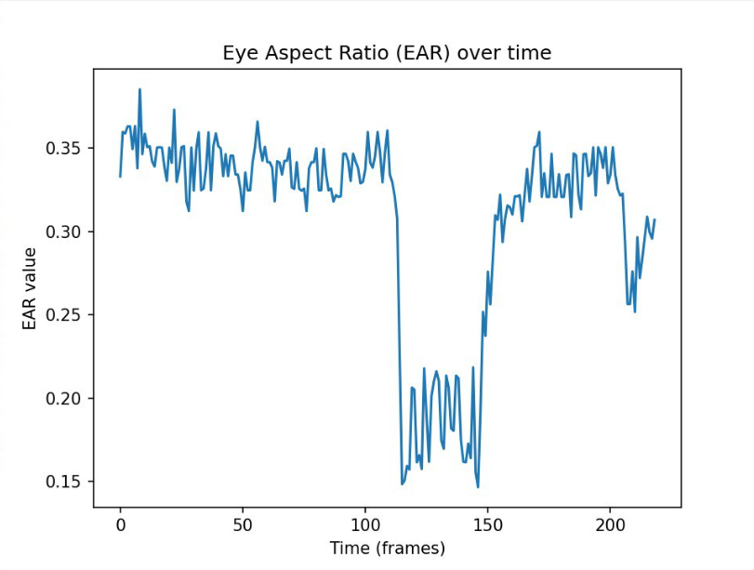

**Fig.4.4: Eye Aspect Ratio(EAR) over time**

### **Mouth Aspect Ratio (MAR)**

**Definition**: MAR is essential for detecting yawning, a key sign of fatigue. By measuring the ratio between specific mouth landmarks (49, 51, 53, 55, 57, 59), we can identify yawning events. A MAR exceeding the threshold (typically around 0.75) indicates yawning, triggering alerts to prevent accidents due to drowsiness. Together, these features enhance real-time monitoring of alertness and safety.

**Facial Landmarks Used**: For the mouth, 12 points are used:

* Points 49, 50, 51, 52, 53, 54, 55, 56, 57, 58, 59, and 60

**Calculation**: The MAR is calculated as follows:



* P1: 49
* P2: 51
* P4: 53
* P7: 55
* P8: 57
* P10: 59

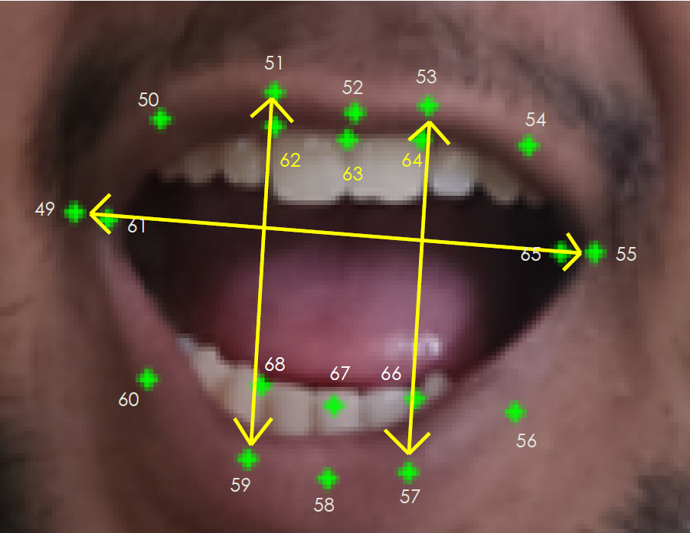

**Fig.4.5: Mouth Aspect Ratio(MAR) Points on test subject**

**Threshold Value**: The typical threshold value for detecting yawning is around 0.75. If the MAR exceeds this threshold for a certain number of frames (e.g., 15 frames), it indicates that the person is yawning.

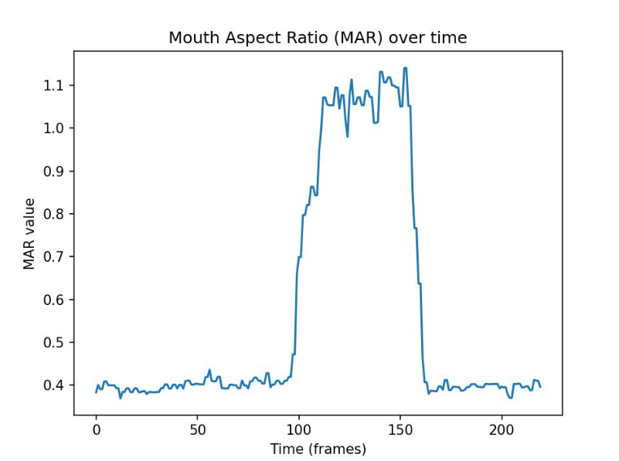

**Fig.4.6: Mouth Aspect Ratio(MAR) over time**

**Nose Bridge Feature**

**Definition**: The nose bridge feature is crucial for detecting head nodding. By tracking the vertical movement of a point on the nose bridge (typically landmark 28), we can monitor head posture. If this point drops significantly below a predefined threshold (line), it suggests the person might be nodding off, prompting an alert.

**Facial Landmarks Used**: The key point used is:

* Point 28

**Calculation**: A point above the nose bridge (Point 28) is defined, and its vertical position is compared to a fixed line placed a certain distance below this point. If the point goes below this line for a certain number of frames, it indicates head nodding or potential drowsiness.

**Classification: Algorithms and Approaches Used**

In the current implementation of the drowsiness detection project, various machine learning algorithms and approaches have been employed to accurately classify and detect drowsiness based on facial features. The primary focus is on analyzing eye and mouth states using specific metrics known as the Eye Aspect Ratio (EAR) and Mouth Aspect Ratio (MAR). These metrics are derived from the positions of facial landmarks, which are identified using dlib’s facial landmark predictor. Here, we will delve into the specific algorithms and feature engineering techniques used, and how they contribute to the overall accuracy and reliability of the system.

**Support Vector Machines (SVMs)**

Support Vector Machines (SVMs) are a powerful and versatile classification algorithm that is particularly well-suited for binary classification tasks. In this project, SVMs are used to classify eye states (open or closed) based on the EAR values. SVMs work by finding the hyperplane that best separates the data into two classes. This hyperplane is determined by maximizing the margin between the closest data points of each class, known as support vectors.

The use of SVMs in classifying eye states is advantageous because they are effective in high-dimensional spaces and are robust to overfitting, especially in cases where the number of dimensions exceeds the number of samples. By analyzing the EAR values over time, the SVM can accurately determine whether the eyes are open or closed, which is a critical indicator of drowsiness.

**Decision Trees**

Decision Trees are another classification algorithm employed in this project, specifically for classifying mouth states (yawning or not yawning) based on MAR values. A Decision Tree is a flowchart-like structure where each internal node represents a test on an attribute, each branch represents the outcome of the test, and each leaf node represents a class label.

Decision Trees are intuitive and easy to interpret, making them suitable for this application. By using MAR values as input, the Decision Tree can efficiently determine whether the mouth is in a yawning state. This is achieved by recursively splitting the data based on the attribute that provides the highest information gain, leading to a tree structure that classifies mouth states with high accuracy.

**CHAPTER- 5**

**RESULTS AND ANALYSIS**

**SNAPSHOTS**

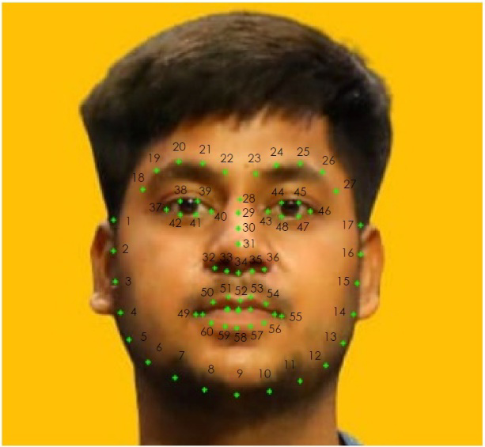 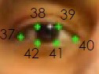

**Fig.5.6: Face Detection Points on Test Subject Fig.5.7: Points on Left Eye**

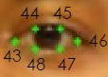 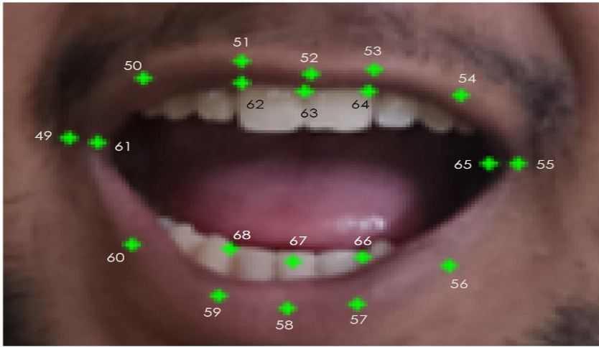

**Fig.5.8: Points on Right Eye Fig.5.9: Mouth Aspect Ratio(MAR) Points on test subject**

**CHAPTER- 6**

**CONCLUSION AND FUTURE SCOPE**

**6.1 Conclusion:**

In conclusion, driver drowsiness is a significant contributor to road accidents globally, posing a severe threat to public safety. Traditional countermeasures often fall short due to their inability to provide real-time detection and immediate responses. This report explored the development of a real-time driver drowsiness detection system leveraging advanced image processing and machine learning techniques. By accurately analyzing visual cues such as facial features, eye states, and head movements, the proposed system aims to provide immediate alerts, thereby preventing accidents and enhancing road safety. The integration of face detection using HOG+SVM, eye detection, blink detection, forehead dot tracking, and an audio-based alert system has shown potential in addressing the limitations of current methods, offering a more effective and reliable solution for real-time drowsiness detection.

**6.2 Future Scope:**

The future scope for real-time driver drowsiness detection systems is promising, with numerous opportunities for advancement. Further refinement and optimization of machine learning algorithms, including the integration of deep learning techniques, can enhance detection accuracy and robustness, enabling more precise and reliable monitoring. Incorporating additional data sources, such as physiological signals and driving behavior, can create comprehensive detection models, facilitating more effective intervention strategies. The development of real-time alert systems will empower drivers with immediate feedback, fostering timely responses and improving road safety.

Moreover, seamless integration of drowsiness detection systems into vehicle manufacturing, along with advancements in autonomous driving technologies, can extend safety measures to a broader range of vehicles. Ethical considerations regarding driver privacy, data security, and informed consent must accompany technological advancements, emphasizing the importance of collaborative research initiatives among stakeholders. By ensuring adherence to ethical guidelines and legal requirements, the development and implementation of these systems can be both effective and responsible.

In essence, the future of driver drowsiness detection systems lies in their continued evolution towards more accurate, accessible, and ethically responsible tools. These advancements will significantly contribute to preventing accidents, saving lives, and ensuring safer driving environments for all.

**CHAPTER- 7**

**REFERENCES**

[1] S. V. Militante and N. V. Dionisio, ‘Real-time facemask recognition with alarm system using deep learning’, in *2020 11th IEEE Control and System Graduate Research Colloquium (ICSGRC)*, 2020, pp. 106–110.

[2] A. Moujahid, F. Dornaika, I. Arganda-Carreras, and J. Reta, ‘Efficient and compact face descriptor for driver drowsiness detection’*, Expert Systems with Applications*, vol. 168, p. 114334, 2021.

[3] K. Parsa, M. Hassall, M. Naderpour, M. Pourreza, and F. Ramezani, ‘A New Alarm System Developing Approach through Graph Modeling’*, IEEE Access*, 2023.

[4] S. Pellegrini, G. Rizzelli, M. Barla, and R. Gaudino, ‘Algorithm Optimization for Rockfalls Alarm System Based on Fiber Polarization Sensing’, *IEEE Photonics Journal*, 2023.

[5] C. Das, C. Bhatt, U. Belim, T. Bhatia, and Others, ‘Smart Alarm System (Drowsiness Detection System Review Paper)’.

[6] S. Waseem, S. R. Abu-Bakar, B. A. Ahmed, Z. Omar, and T. A. E. Eisa, ‘DeepFake on Face and Expression Swap: A Review’, *IEEE Access*, 2023.

[7] N. Li et al., ‘Chinese face dataset for face recognition in an uncontrolled classroom environment’*, IEEE Access*, 2023.

[8] H. Qi, C. Wu, Y. Shi, X. Qi, K. Duan, and X. Wang, ‘A real-time face detection method based on blink detection’*, IEEE Access*, vol. 11, pp. 28180–28189, 2023.

[9] S. S. Dash, ‘Face Recognition and Face Detection Benefits and Challenges’, no. July, pp. 177–191, 2023.

[10] S. V. Militante and N. V. Dionisio, ‘Deep learning implementation of facemask and physical distancing detection with alarm systems’, in 2020 third international conference on vocational education and electrical engineering (ICVEE), 2020, pp. 1–5.

[11] G. de la Cruz, M. Lira, O. Luaces, and B. Remeseiro, ‘Eye-LRCN: a long-term recurrent convolutional network for eye blink completeness detection’*, IEEE Transactions on Neural Networks and Learning Systems*, 2022.

[12] J. Cai, X. Liao, J. Bai, Z. Luo, L. Li, and J. Bai, ‘Face fatigue feature detection based on improved DS model in complex scenes’*, IEEE Access*, 2023.

[13] H. A. Madni, A. Raza, R. Sehar, N. Thalji, and L. Abualigah, ‘Novel Transfer Learning Approach for Driver Drowsiness Detection Using Eye Movement Behavior’, *IEEE Access*, 2024.

[14] S. Hong, Y. Kim, and T. Park, ‘“Blinks in the Dark”: Blink Estimation with Domain Adversarial Training (BEAT) Network’*, IEEE Transactions on Consumer Electronics*, 2023.

[15] M. Shahbakhti et al., ‘Fusion of EEG and eye blink analysis for detection of driver fatigue’, *IEEE Transactions on Neural Systems and Rehabilitation Engineering*, 2023.

[16] R. M. Salman, M. Rashid, R. Roy, M. M. Ahsan, and Z. Siddique, ‘Driver drowsiness detection using ensemble Convolutional Neural Networks on YawDD’, *arXiv [cs.CV]*, 19-Dec-2021

[17] F. Safarov, F. Akhmedov, A. B. Abdusalomov, R. Nasimov, and Y. I. Cho, *‘Real-time deep learning-based drowsiness detection: leveraging computer-vision and eye-blink analyses for enhanced road safety’*, Sensors, vol. 23, no. 14, p. 6459, 2023.

*[18] Y. Albadawi, A. AlRedhaei, and M. Takruri, ‘Real-time machine learning-based driver drowsiness detection using visual features’, Journal of imaging,* vol. 9, no. 5, p. 91, 2023.

[19] W. Deng and R. Wu, *‘Real-time driver-drowsiness detection system using facial features’, Ieee Access,* vol. 7, pp. 118727–118738, 2019.

[20] M. M. Hasan, C. N. Watling, and G. S. Larue*, ‘Validation and interpretation of a multimodal drowsiness detection system using explainable machine learning’, Computer Methods and Programs in Biomedicine,* vol. 243, p. 107925, 2024.

[21] S. Díaz-Santos, Ó. Cigala-Álvarez, E. Gonzalez-Sosa, P. Caballero-Gil, and C. Caballero-Gil, *‘Driver identification and detection of drowsiness while driving’, Applied Sciences,* vol. 14, no. 6, p. 2603, 2024.

[22] M. H. Wang et al., *‘AI-based Advanced approaches and dry eye disease detection based on multi-source evidence: Cases, applications, issues, and future directions’, Big Data Mining and Analytics,* vol. 7, no. 2, pp. 445–484, 2024.

[23] H. Beles, T. Vesselenyi, A. Rus, T. Mitran, F. B. Scurt, and B. A. Tolea*, ‘Driver Drowsiness Multi-Method Detection for Vehicles with Autonomous Driving Functions’, Sensors,* vol. 24, no. 5, p. 1541, 2024.

[24] S. Das, S. Pratihar, B. Pradhan, R. H. Jhaveri, and F. Benedetto, ‘*IoT-Assisted Automatic Driver Drowsiness Detection through Facial Movement Analysis Using Deep Learning and a U-Net-Based Architecture’, Information*, vol. 15, no. 1, p. 30, 2024.

[25] H. U. R. Siddiqui *et al., ‘Ultra-Wide Band Radar Empowered Driver Drowsiness Detection with Convolutional Spatial Feature Engineering and Artificial Intelligence’, Sensors*, vol. 24, no. 12, p. 3754, 2024.